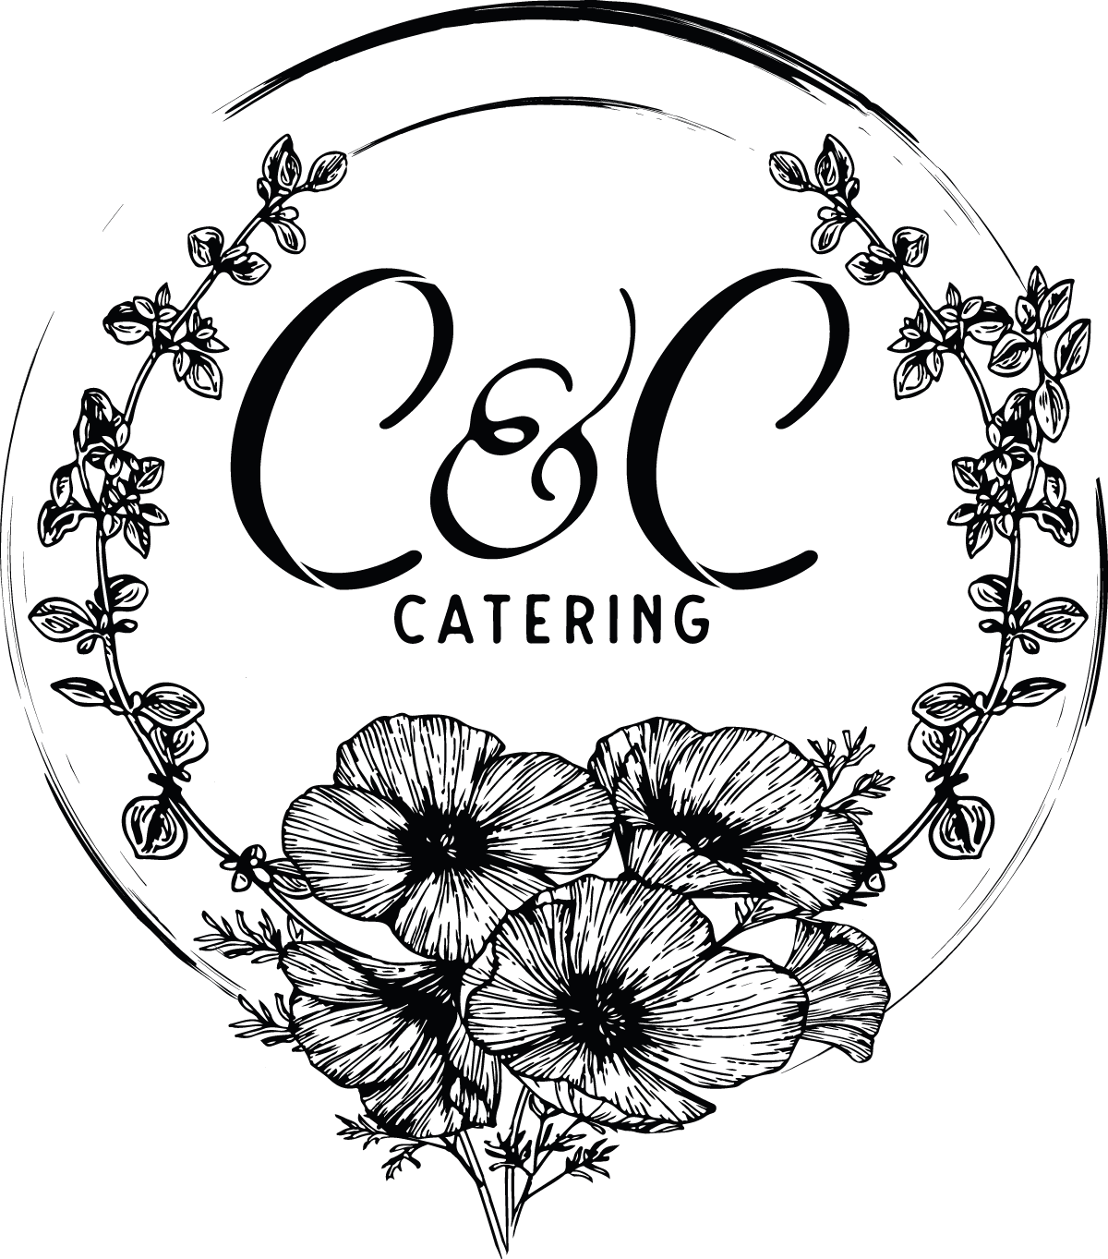

Breakfast and Lunch Catering Menu 2020

530-586-8126

WWW.CCCATERING530.COM

C_C_CATERING@YAHOO.COM

Minimum of 10 Guests per Item Ordered

Breakfast

Build Your Own 1 Main 2 Sides $10. 2 Main 2 Sides $12

Main: Buttermilk Pancakes, Belgium Waffles, Vanilla Brandy French Toast, Biscuits & Country Gravy

Sides: Applewood Smoked Bacon, Country Sausage Link, Sausage Patty, Chicken Sausage, Chorizo, Scrambled Eggs, Roasted Rosemary Potatoes

Specialty Breakfast (Includes Fresh Sliced Fruit and Potatoes)

Champagne Egg Casserole- Country Sausage, Eggs, Green Onions, Mushrooms, Colby Jack Cheese and Champagne $12

Quiche Lorraine- Smoked Bacon and Swiss $12

Continental Breakfast

Fresh Sliced Fruit, Muffins, Danishes, Scones, Hard Boiled Eggs, Yogurt and Granola $8

Bagel Bar

Assorted Bagels, Cream Cheeses, Smoked Salmon, Cucumbers, Pickled Red Onions and Sliced Strawberries $11

Beverages

Coffee and Tea Bar
Fresh Brewed Coffee, Regular and/or Decaffeinated, Assorted Tea Bags, Assorted Creamers and Sugars $2

Fruit Infused Water
Orange Juice
Pineapple Juice
Apple Juice

Sandwiches
(Served with Choice of Soup or Side Salad)

Cubano Sandwich with Braised Pork, Shaved Ham, Swiss Cheese, Mustard and Pickles $14
Club Sandwich with Turkey, Ham, Cheddar, Bacon, Lettuce, Tomato, Avocado and Garlic Aioli $14
Grilled Chicken and Havarti Sandwich with Roasted Bell Pepper Aioli on Toasted French Roll $14
BBQ Chicken Sandwich with Cheddar, Grilled Onions and Bacon $12
Tri-Tip Sandwich with Cheddar, Green Chili and Rosemary Aioli on Sourdough $14
Meatball Sliders on Sweet Roll with Melted Provolone and Garden Basil Marinara $10
Build Your Own Sandwich Bar – Assorted Breads, Deli Meats, Cheeses, Condiments and Toppings $12

Barbeque
1 Meat 2 Sides $12.50 2 Meats 2 Sides $15

Meats: Chicken Breast, Chicken Thighs, Tri-Tip and St. Louis Style Ribs
Sauces: Classic BBQ, Apple Bourbon, Roasted Garlic, Corona Lime, Carolina Mustard and Wild Berry
Sides: Grilled Vegetables, Roasted Potatoes, Mashed Potatoes, Bourbon and Bacon Baked Beans, Ranch Style Beans and Fresh Fruit

All BBQ Selections Include Corn Bread and Side Salad

Across the Border
Taco, Fajita or Enchilada Bar: 1 Meat $15 2 Meats $17

Flour and/or Corn Tortillas
Meats: Tequila Grilled Chicken, Carne Asada, Pork Carnitas and Ground Beef
Rice: Cilantro Lime or Spanish
Beans: Black, Refried or Whole Pinto
Includes: Side Salad, Chips, Salsa, Shredded Cabbage, Sour Cream, Guacamole, Jalapeños and Limes
Specialty Dishes:
Chicken Mole $14
Al Pastor Pork $13
Chicken Chile Verde $13
Chimichurri Steak $15
Chicken or Steak with Mango Jalapeño Salsa $13
Specialty Dishes Include Side Salad, Rice, Beans, Chips and Salsa

Far East Selections
Pho Bar: $12
Meats: Chicken, Steak, Shrimp or Tofu.
Includes: Rice Noodles, Onions, Jalapeños, Bean Sprouts, Basil, Cilantro, Green Onions and Lime
Build Your Own Chinese Buffet: 1 Main 2 Sides $13 2 Main 2 Side $15
Main: Mongolian Beef, Beef and Broccoli, Sweet and Sour Pork, Kung Pao Chicken and Teriyaki Chicken.
Sides: Steamed Rice, Pan Fried Rice, Coconut Ginger Rice, Chow Mein and Stir-Fried Vegetables

A Taste of Italy
Build Your Own Pasta Buffet: $13
(Includes Side Salad and Garlic Bread)

Pasta: Penne, Fettuccini and Spaghetti
Sauce: Garden Marinara, Parmesan Cream (Alfredo) and Basil Pesto
Proteins: Chicken $3, Meatballs $3, Italian Sausage $3, Shrimp $4 and/or Scallops $4
Vegetables: Roasted Garlic, Zucchini, Bell Pepper, Green Onion, Mushrooms, Black Olives and Sun-Dried Tomato
Specialty Dishes:
Sicilian Sausage Lasagna with Sun Dried Tomato Cream Sauce $17
Vegetarian Lasagna with Basil Marinara $15
Baked Ziti Pasta with Provolone, Mozzarella, Parmesan and Red Wine Marinara (Vegetarian) $14
Chicken Marsala served with Roasted Baby Potatoes $17
Chicken Parmesan served with Penne and Marinara $17
Specialty Dishes Include Side Salad and Garlic Bread

Entrée Salads
(all salads served with local artisan sourdough bread)

Cobb Salad with Grilled Chicken Breast, Bacon, Tomatoes, Hard Boiled Eggs, Avocado, Green Onion and Bleu Cheese $13
Salmon Salad with Spinach, Grape Tomatoes, Pickled Red Onion and Feta Cheese $14
Steak Salad with Caramelized Onion, Brie Cheese, and Fire Roasted Tomatoes on a bed of Romaine $14
Asian Chicken Salad with Napa Cabbage, Cilantro, Green Onion, Carrot and Fried Wontons with Sweet Chili Vinaigrette $13

Soups
(all soups served with local artisan sourdough bread)
(Available as a Side or Main)

Cheddar Beer
Tomato Basil
Carrot Ginger
Chicken Tortilla
Italian Sausage and Lentil
Beef Barley
Potato Leek
Broccoli Cheddar
Cream of Mushroom

Side Salads

Garden Salad with Carrots, Radish and Tomato
Mixed Greens Salad with Strawberries, Cucumber, Mint and Feta Cheese
Romaine Salad with Black Beans, Pico de Gallo, Avocado, Feta Cheese and Cilantro Vinaigrette

Caesar salad with Grape Tomatoes, Shaved Parmesan and Garlic Croutons
Penne Pasta Salad with Tomato, Artichoke Heart, Olives and Basil Vinaigrette
Udon Noodle Salad with Cucumber, Bell Pepper, Cilantro, Green Onion and Ginger Peanut Vinaigrette
Dressing Options: Ranch, Bleu Cheese, Italian, Poppy Seed, Citrus Vinaigrette, Cider Vinaigrette

Dessert

Fresh Baked Cookies $2

Decadent Chocolate Brownies $2

Fresh Fruit Platter with Berries. $3

N.Y. Style Cheesecake with Caramel Sauce $4

Apple or Peach Cobbler with Whipped Cream $4

Bananas Foster Bread Pudding $4

Beverages

Fruit Infused Water -Included

Minted or Regular Iced Tea -Included

Strawberry or Regular Lemonade -Included

Coffee Bar $2

Hansen’s Sodas $2

All Caterings Include Fruit Infused Water and Tea or Lemonade

Disposable Wares are Included

